Employee Accident Investigation Form

Instructions: Employees shall use this form to report for all workers compensation claims. This helps us to identify and correct hazards before they cause serious injuries. This form shall be completed by employees as soon as possible and submitted to Prescient National Insurance Services by email: claims@prescientnational.com or by fax: (704) 927-2867 when a claim is filed.

Your Name: | Job title:
Supervisor:
Have you told your supervisor about this injury? Yes No
Date of injury: |  | Time of injury:
What were you doing at the time and how did the injury occur?
Where, exactly, did it happen?
What parts of your body were injured?
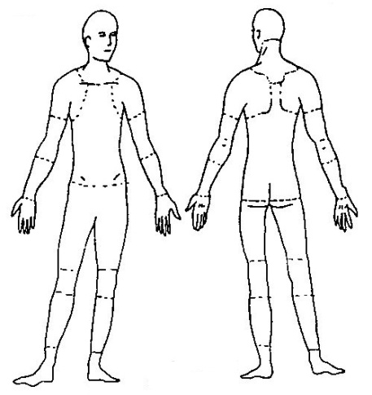
Did you lose time from work? Yes No
If so, when did the time out of work start?_____________ When did the time out of work end? _____________
Names of witnesses (if any):
Did you see a doctor about this injury/illness? Yes No
If yes, whom did you see? _________________________________________________________
Doctor’s phone number: ___________________ Date & time of doctor’s appointment: _____________________
Has this part of your body been injured before? Yes No
If yes, when? ____________________
Name of Treating Physician: _______________________________________________________
Did you have any of the following treatments? MRI Surgery Diagnostic Testing Other
If “Other”, describe in detail: ___________________________________________________________________
___________________________________________________________________________________________
Did the Physician write any prescription(s) due to this injury? Yes No
If so, please list medications:______________________________________________________________________
Sex: Female Male Date of Birth: _________ Height: _________ Weight: _________
List any current medical problems/conditions: _____________________________________________________________________________________________
Were you taking any medications prior to the accident? Yes No
If yes, please list: ________________________________________________________________
Any Prior Insurance Workers’ Compensation Claims? Yes No
If so, when? _____________________________________________________________________
Is so, who was the treating physician? ________________________________________________
What body part(s)? _______________________________________________________________
Your signature: |  | Date:

